Name: A.Reddy Sulochana
Reg.No: 192372370

Exp.No.16 Feed Forward Neural Network
01.08.26

Aim:
To implement a simple Feed Forward Neural Network using Python by processing the input values through weights, bias, and an activation function to produce the desired output.
Algorithm:
- Start the program.
- Read the binary input values from the user.
- Initialize the weights and bias values.
- Multiply each input by its corresponding weight.
- Calculate the weighted sum of all inputs.
- Add the bias value to the weighted sum.
- Apply the activation function to the calculated value.
- Display the final output of the neural network.
- Stop the program.
Program:
x1 = int(input("Enter first input (0 or 1): "))
x2 = int(input("Enter second input (0 or 1): "))
# AND gate using a simple feed-forward neuron
weights = [1, 1]
bias = -1.5
net = x1 * weights[0] + x2 * weights[1] + bias
if net >= 0:
output = 1
else:
output = 0
print("Output =", output)

Input:
Enter first input (0 or 1): 1
Enter second input (0 or 1): 1
Output:
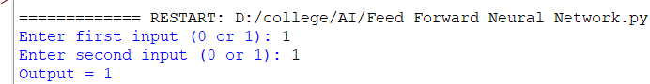

Result:
Thus, the Feed Forward Neural Network was implemented successfully using Python. The program processed the input values through weights and bias, applied the activation function, and generated the correct output based on the given inputs.

